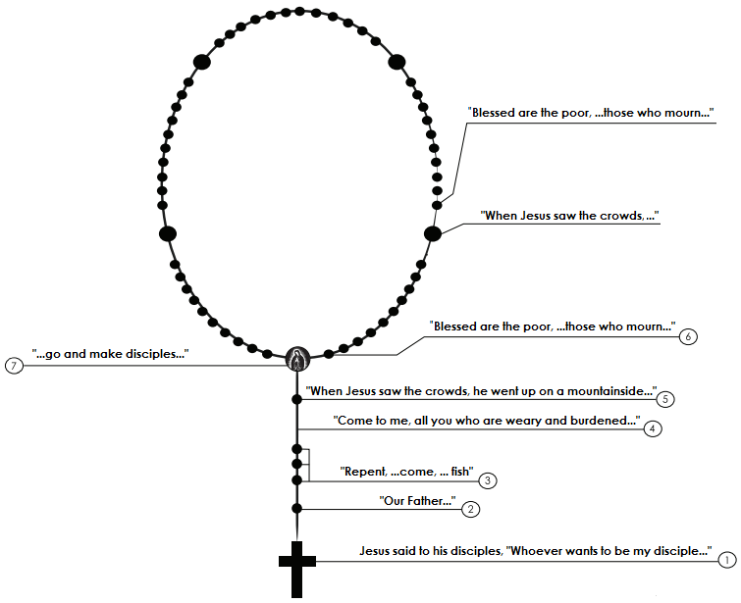
The Kingdom Rosary
1. The Cross
Jesus said to his disciples, “Whoever wants to be my disciple must deny himself and take up his cross and follow me" - Mt 16:24
2. The large bead
"Our Father..." - Mt 6:9-13
3. The three small beads
"Repent, for the kingdom of heaven has come near… Come, follow me, …. And I will make you fishers of men" - Mt 4:17, 19
4. After the small beads
"Come to me, all you who are weary and burdened, and I will give you rest. Take my yoke upon you and learn from me, for I am gentle and humble in heart, and you will find rest for your souls. For my yoke is easy and my burden is light" - Mt 11:28-30
5. The large bead
"When Jesus saw the crowds, he went up on a mountainside and sat down. His disciples came to him, and he began to teach them. He said..." - Mt 5:1-2
6. The smaller beads
1. “Blessed are the poor in spirit, for the kingdom of heaven is theirs..." - Mt 5:3
2. "...Blessed are those who mourn, for they will be comforted" - Mt 5:4
3. "...Blessed are the gentle, for they will inherit the earth" - Mt 5:5
4. "...Blessed are those who hunger and thirst for righteousness, for they will be filled" - Mt 5:6
5. "...Blessed are the merciful, for they will receive mercy" - Mt 5:7
6. "...Blessed are the pure in heart, for they will see God" - Mt 5:8
7. "..Blessed are the peacemakers, for they will be called children of the Most High" - Mt 5:9
8. "...Blessed are those who are persecuted because of righteousness, for theirs is the kingdom of heaven" - Mt 5:10
9. “...Blessed are you when people insult you, persecute you and falsely say all kinds of evil against you because of me. Rejoice and be glad, because great is your reward in heaven, for in the same way they persecuted the prophets who were before you" - Mt 5:11-12
10. Glory Be to the Father, ...
7. The Medal
“All authority in heaven and on earth has been given to me. Therefore go and make disciples of all nations, baptizing them in the name of the Father and of the Son and of the Holy Spirit, and teaching them to obey everything I have commanded you. And surely I am with you always, to the very end of the age.” - Mt 28:17-20

